**ETHICAL HACKING**

**EXPERIMENT 8 – TRACEROUTE , PING , IPCONFIG , IFCONFIG , NETSTAT**

**INDHUMATHI V**

**192124215**

**tracert saveetha.com**

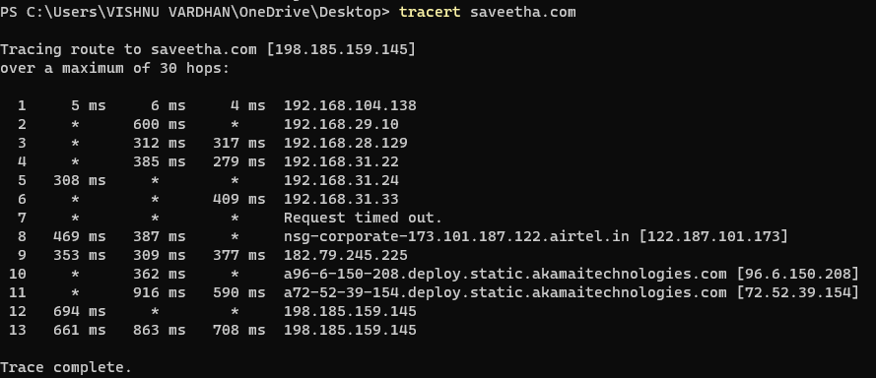

**Windows ipconfig**

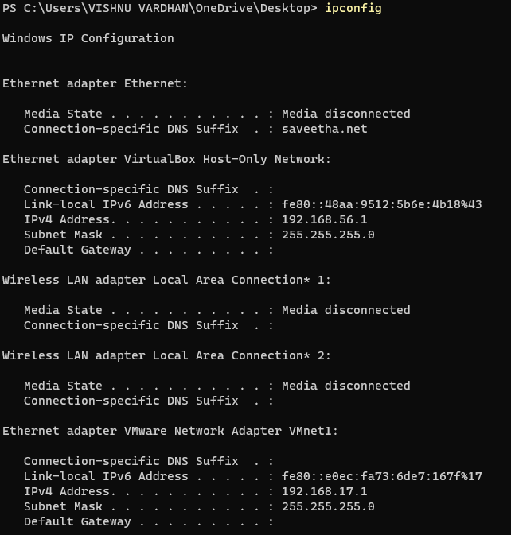

**Linux ifconfig**

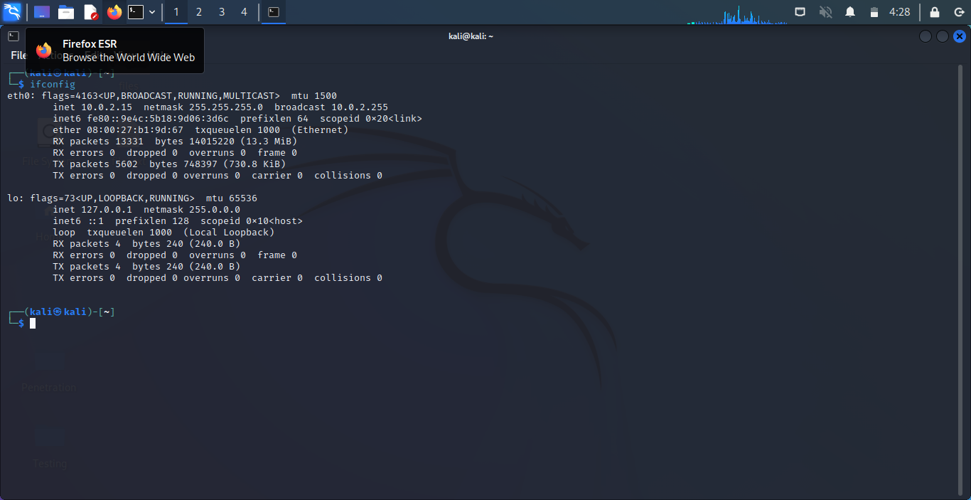

**Ping command**

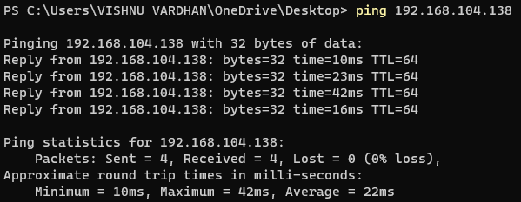

**Netstat command**

